**Luxor university**

**Faculty of Computer and Information**

**Computer Science Department**

**Elserag**

**A Literacy Platform for Special Needs**

**Graduation Project Part II**



**Under Supervision**

**Dr. Hussein Elshafie**

**Dr. Hosny Ahmed Abbas**

**Eng. Ibrahim Elsayed**

**Submitted by**

**Mohamed AbdElrahman Elkhlawy**

**Amina Younis Mohammed**

**Manar Hussein Mohamed**

**Norhan Nageh Alabad**

**Omar Mohamed Elhassan**

**Sarah Nabil Kamel**

**2024**

**ABSTRACT**

**Now** we want to know more about the people with special needs.

People with special needs encompass a diverse and heterogeneous group of individuals who face various physical, intellectual, sensory, or developmental challenges that may require additional support and accommodation. These challenges can result from conditions such as autism, Down syndrome, cerebral palsy, ADHD, dyslexia, visual or hearing impairments, and more. Special needs individuals often require tailored educational, social, and healthcare services to meet their unique requirements and maximize their potential for independent living and participation in society.

**Blindness**, a sensory disability, creates unique challenges related to access to information, communication, mobility, and independence.

Focusing on blindness as the primary disability in our project represents a significant step towards fostering inclusivity and empowerment for individuals with visual impairments.

In our project, we aim to develop a **literacy platform** that caters specifically to the needs of **blind individuals**. This entails creating accessible digital content, leveraging assistive technologies, and adopting inclusive design principles to ensure that blind users can acquire and enhance their literacy skills effectively. By prioritizing blindness in our project, we contribute to the broader mission of making education and information accessible to all, regardless of their visual abilities.

Our project holds the potential to transform the lives of blind individuals, empowering them with the knowledge and skills necessary for personal growth, societal participation, and increased opportunities.

Contents

**ABSTRACT** 2

List of Abbreviation 6

**Chapter 1** 7

Introduction 8

❖ Motivation 8

❖ Problem Statement 9

❖ Overview 9

**Chapter 2** 11

Introduction 12

Related Work (Table 1) 12

Conclusion 13

**Chapter 3** 14

Domain Analysis 15

❖ Key Phases 15

❖ Key Principles 16

Risks (Table 2) 18

Constrains 20

Project plan (Table 3) 21

Feasibility Study 22

Overall Feasibility 23

Next Steps 23

Quality Assurance Plan 23

1. User-Centric Approach 23

2. Technical QA 24

3. Content Quality 24

4. Ongoing Monitoring 24

Tools and Techniques for Quality Assurance 24

Benefits of a Strong QA Process: 25

System Requirements 25

1. Hardware and Software Requirements: 25

2. Accessibility Requirements: 26

Additional Considerations: 27

Techniques and tools 27

❖ Development Tools 27

❖ Assistive Technology Integration Techniques 27

❖ Additional Techniques 28

**Chapter 4** 29

System Use-Cases 30

❖ Main Use Case (Figure 1) 30

❖ Future Use Case (Figure 2) 31

Use Case Description (Use case scenario) 31

❖ Main Use Case Diagram 31

❖ Future Use Case Diagram 43

System Architecture (Figure 3) 46

Analysis Class 47

❖ State Diagram (Figure 4-6) 47

❖ Data flow diagram (Level Zero diagram) (Figure 7) 50

❖ Context Diagram (Figure 8) 51

Interaction Class Diagram 52

❖ Sequence Diagram (Figure 9-12) 52

Design Class (Figure 13) 56

❖ Class Diagram 56

Database Schema (Figure 14) 57

ER Diagram (Figure 15) 58

**Chapter 5** 59

Programming languages and Frameworks 60

❖ Front-End Part 60

❖ Back-End Part 60

Algorithms 60

Application Essentials 62

❖ Front-End Implementation (Figure 16-21) 62

❖ Back-End Implementation (Figure 22-30) 66

Testing Scenarios 70

❖ Front-End Testing (Table 4) (Figure 31-34) 70

❖ Back-End Testing (Figures 35-38) 75

**Chapter 6** 77

First Feature 🡺 Braille System 78

Second Feature 🡺 Screen Readers 79

Third Feature 🡺 Variety of Users 80

Fourth Feature 🡺 Communication between Different Types of Users 81

Conclusion 82

**Chapter 7** 83

Conclusion 84

Future work 85

References 85

❖ Unified Modeling Languages (UML) 85

❖ User Interfaces and Experience (UI / UX) 85

❖ Information about Special Needs 86

❖ Problem with Special Needs 86

❖ Solution for their problems 87

❖ Implementation (packages & references): 88

List of Abbreviation

|  |  |
| --- | --- |
| **Keyword** | **Meaning** |
| **Braille System** | Braille is a system of reading and writing that uses raised dots. People who are blind or visually impaired can read Braille by touch. |
| **Dart** | Dart is an open-source programming language created by Google. It's known for being versatile, allowing you to build apps for web, mobile, desktop, and even servers. It's designed to be clear and efficient, with features like type safety to help catch errors early. |
| **Flutter** | Flutter is an open-source framework by Google for building beautiful apps. It allows you to code once and deploy your app on multiple platforms like mobile (Android, iOS), web, and even desktop. Think of it as a toolbox with pre-built elements and tools to create visually appealing apps efficiently. |
| **PHP** | PHP excels at server-side scripting. Mobile apps can leverage PHP to handle tasks like user authentication, database interactions (storing and retrieving data), and processing information. Essentially, PHP acts as the brain of the app, handling data and logic. |
| **MySQL** | MySQL is a popular choice for storing app data on a server. The mobile app communicates with a server-side script (often PHP) that interacts with the MySQL database to manage user data, app content, or any information the app needs to function. |

**Chapter 1**

**System Overview**

Introduction

* Motivation

**Unveiling Hidden Potential: A Literacy Platform for a World Unbound by Sight**

This project arises from a fundamental curiosity about the vast spectrum of human experience. We seek to delve deeper into the unique realities of individuals with special needs, understanding the challenges they face and the potential waiting to be unlocked.

Our focus hones in on the sensory realm, specifically the world experienced by those living with blindness. This condition presents a distinct set of obstacles in accessing information, hindering communication, and limiting independence. By prioritizing blindness as the lens for our project, we embark on a journey towards inclusivity and empowerment.

We envision a digital platform crafted to bridge the literacy gap faced by blind individuals. This platform will act as a conduit, seamlessly integrating accessible content, cutting-edge assistive technologies, and inclusive design principles. Through this multifaceted approach, blind users will be equipped to acquire and refine their literacy skills with unprecedented ease and efficacy.

However, our ambition extends far beyond the platform itself. It serves as a stepping stone towards a more equitable future, where education and information are not restricted by visual limitations. We strive to dismantle barriers, fostering a world where knowledge transcends boundaries and empowers all individuals to reach their full potential.

This project is more than just about literacy; it's about unlocking the boundless potential within each person, regardless of their ability to see. It's about creating a world where everyone has the tools and resources to thrive.

* **Problem Statement**

In a world where information is a cornerstone of empowerment and progress, there exists a profound issue that warrants immediate attention. **Individuals with special needs**, including those with physical disabilities, cognitive impairments, or sensory challenges, often face significant barriers when it comes to accessing and benefiting from traditional literacy education. Existing educational materials and platforms are not always designed to cater to the diverse needs of this population. This lack of inclusivity and accessibility can limit their opportunities for personal growth, communication, and participation in society.

* Overview

This project seeks to develop a groundbreaking literacy platform specifically designed to empower individuals who are blind. Recognizing the unique challenges faced by blind users in accessing information and honing literacy skills, this platform will bridge the gap through:

* **Accessible Content:** The platform will curate and provide content optimized for blind users, ensuring compatibility with assistive technologies.
* **Assistive Technology Integration:** The platform will seamlessly integrate with screen readers, Braille displays, and other assistive technologies to provide a smooth and intuitive user experience.
* **Inclusive Design Principles:** The platform will be designed with accessibility at its core, prioritizing features like clear navigation, ease to use and many other interesting features.

By combining these elements, the platform aims to:

* **Enhance Literacy Skills:** Provide blind users with the tools and resources necessary to effectively learn, read, write, and improve their overall literacy.
* **Promote Independence:** Foster greater independence by empowering users with the ability to access and utilize information independently.
* **Bridge the Digital Divide:** Close the accessibility gap in the digital world, ensuring equal access to education and information for all.

This project goes beyond just literacy skills. It strives to create a world where individuals who are blind have the resources and support to actively participate in society, achieve personal growth, and unlock their full potential.

**Chapter 2**

**Related Work**

Introduction

This review explores apps designed to boost literacy for blind individuals. We'll look at what each app offers, how it's used, and its pros and cons.

Related Work (Table 1)

|  |  |  |  |  |  |
| --- | --- | --- | --- | --- | --- |
| Related Applications | Description | Key features | User Interface | Pros | Cons |
| Be my Eyes | **Connects blind users with sighted volunteers for assistance.** | **Live video assistance**  **Support various tasks** | **Simple and user-friendly, utilizing video calls for assistance.** | **Reading text, identifying objects, navigating surroundings** | **Relies on volunteer availability**  **Unsupportive UI** |
| Smart Voice(الناطق) | **Converts type of text or type of data into a recognized or spoken word voice** | **Adjustable reading speed**  **Text-to-speech for different document types** | **Simple touch or voice commands with customizable settings.** | **Easy access to information**  **Improves listening and comprehension skills** | **Pronunciation may not be perfect**  **Struggle with some extensions files** |
| Braille Academy | **Teaches braille to blind individuals.** | **Interactive braille lessons**  **Voice-guided instructions** | **Intuitive and tactile interface with audio feedback.** | **Enhances braille literacy skills**  **Independence in reading and writing** | **Limited advanced lessons**  **Limited advanced lessons** |

Conclusion

In the world of literacy apps for the blind, we've seen a variety of tools with unique strengths. While user-friendly features contribute to inclusivity, challenges like learning curves remain. Recognizing progress and addressing these challenges will shape a more accessible future for education and technology for everyone.

**Chapter 3**

**Domain Analysis and Technique**

Domain Analysis

The development of the literacy platform for individuals with special needs will follow an **iterative** and **incremental** model, combining elements of the **Agile** and **Spiral** process models. This hybrid approach is chosen to accommodate the evolving nature of user requirements, the need for continuous feedback, and the complexity of developing a solution that addresses diverse learning needs.

* Key Phases

1. **Requirements Gathering:**

* Engage with educators, special education institutions, individuals with special needs, and other stakeholders to gather detailed and evolving requirements.
* Conduct usability studies to understand user preferences and challenges.

1. **Planning:**

* Define the project scope, objectives, and constraints.
* Develop a detailed project plan, including timelines, resource allocation, and risk management strategies.

1. **Design and Prototyping:**

* Create initial design prototypes based on gathered requirements.
* Seek feedback from the target audience, educators, and individuals with special needs to refine the design iteratively.

1. **Implementation and Testing:**

* Develop the core functionalities of the platform in incremental stages.
* Conduct continuous testing and debugging to ensure the reliability, security, and performance of each implemented feature.

1. **Release and User Feedback:**

* Release functional increments of the platform to a limited user group for beta testing.
* Gather user feedback to identify areas for improvement and iterate on the design and functionality.

1. **Iterative Development:**

* Based on user feedback and testing results, iterate on the design and implement additional features.
* Regularly release updates to address identified issues and enhance the platform.

1. **Training and Support:**

* Develop comprehensive training programs for educators and administrators.
* Provide ongoing technical support and address user queries and issues.

1. **Monitoring and Evaluation:**

* Implement data analytics to monitor user engagement, track progress, and gather insights into the platform's effectiveness.
* Regularly evaluate the platform's impact on literacy skills and educational outcomes.
* Key Principles

1. **User-Centric Development:**
   * Prioritize user feedback and involve end-users in the design and testing phases to ensure the platform aligns with their needs.
2. **Agile Development Practices:**
   * Embrace agile principles such as iterative development, collaboration, and adaptability to respond to changing requirements and user expectations.
3. **Continuous Improvement:**
   * Regularly assess the effectiveness of the platform and implement updates to address emerging needs, technological advancements, and educational research.
4. **Accessibility Compliance:**
   * Adhere to accessibility standards throughout the development process, ensuring that the platform remains inclusive and usable for individuals with diverse abilities.
5. **Security Integration:**
   * Integrate security measures at every stage of development to safeguard user data and maintain the trust of educators, learners, and administrators.
6. **Stakeholder Collaboration:**
   * Foster open communication and collaboration among stakeholders, including educators, individuals with special needs, special education institutions, and advocacy groups.

Risks (Table 2)

|  |  |  |  |
| --- | --- | --- | --- |
| **Strategy** | **Priority** | **Effects** | **Risk** |
| • Develop partnerships with publishers and organizations to convert existing content to accessible formats.  • Integrate tools for users to contribute their own accessible content.  • Prioritize creation of high-demand materials in accessible formats. | **High**.  Content is the foundation of the platform. | A lack of accessible content on the platform could limit its usefulness and user engagement. | **Limited Content Availability** |
| • Conduct thorough testing with a diverse range of assistive technologies.  • Follow accessibility standards and guidelines (WCAG) during development.  • Design the platform for modularity to allow for future compatibility with emerging technologies. | **High**.  Ensuring seamless integration is crucial for platform adoption. | Compatibility issues between the platform and various assistive technologies could hinder user experience. | **Technological Compatibility Issues** |
| • Involve blind users in the design process through user testing and feedback sessions.  • Utilize screen reader compatibility tools during development.  • Ensure clear navigation, ease to use, and any other alternative solutions to provide perfect UI. | **High**.  An accessible interface is essential for user independence. | A poorly designed UI, lacking features like clear navigation and ease to use, could exclude users. | **Limited User Interface (UI) Accessibility** |
| • Partner with blindness advocacy organizations and educational institutions to promote the platform.  • Develop engaging tutorials and user guides tailored for blind users.  • Consider offering incentives and gamification elements to encourage platform exploration. | **Medium**. Initial user base is crucial, but the platform's value will spread with success. | Low user adoption could render the platform ineffective and limit its impact. | **User Adoption and Awareness** |
| • Explore a combination of funding models like grants, subscriptions for institutions, and partnerships with corporations.  • Implement features that allow for future monetization options accessible to blind users (e.g., premium content partnerships).  • Develop a strong project proposal highlighting the platform's social impact for potential investors. | **Medium**. Initial funding is crucial, but long-term planning is essential. | Without a sustainable funding model, the platform's long-term viability could be compromised. | **Long-Term Funding and Sustainability** |

By proactively addressing these potential risks through the proposed mitigation strategies, the platform can achieve its goal of empowering blind individuals and fostering a more inclusive digital world.

Constrains

Our journey to build this literacy platform might encounter some roadblocks. Here's a look at a few:

1. **Finding the right treasures** 🡺 Imagine a vast library, but some books haven't been converted into formats accessible for our users. We'll need to find ways to make more "books" accessible on the platform.
2. **Making things talk together 🡺** Different tools people use to access information (like screen readers) might not always work smoothly with our platform. We need to ensure everything chats and works together seamlessly.
3. **Building a clear and welcoming space 🡺** The platform's design needs to be clear and easy to navigate, like a well-organized room. This is important so everyone feels comfortable exploring and finding what they need.
4. **Spreading the word 🡺** Even if we build a fantastic library, if people don't know it exists, it won't be much use. We need to find ways to let people know about the platform and how it can help them.
5. **Keeping the lights on 🡺** Just like any library needs resources to stay open, our platform will need ongoing support to keep it running smoothly. We'll need to find ways to ensure it has a sustainable future.

These are some of the challenges that we might face, but by being creative and finding solutions, we can build a platform that truly empowers those who use it.

Project plan (Table 3)

|  |  |  |  |  |  |  |  |  |
| --- | --- | --- | --- | --- | --- | --- | --- | --- |
| **Phase** | **Nov** | **Dec** | **Jan** | **Feb** | **Mars** | **April** | **May** | **June** |
| **Gathering Information** |  |  |  |  |  |  |  |  |
| **Define Requirements** |  |  |  |  |  |  |  |  |
| **Analysis** |  |  |  |  |  |  |  |  |
| **Design** |  |  |  |  |  |  |  |  |
| **Implementation** |  |  |  |  |  |  |  |  |
| **Develop Elserag Platform** |  |  |  |  |  |  |  |  |
| **Testing and Final Discussion** |  |  |  |  |  |  |  |  |

Feasibility Study

This feasibility study assesses the viability of developing a literacy platform specifically designed for blind individuals. Here's an analysis of key factors:

**1. Market Need:**

* High demand: Blindness affects millions globally, and there's a critical need for accessible literacy resources.
* Limited existing solutions: While some platforms exist, a comprehensive solution with accessible content and assistive technology integration is lacking.

**2. Technical Feasibility:**

* Technology exists: The core technologies for building the platform and integrating assistive technologies are readily available.
* Development challenges: Ensuring compatibility across various assistive technologies and creating a user-friendly interface require expertise.

**3. Economic Feasibility:**

* Potential funding sources: Grants, subscriptions for institutions, and partnerships offer funding opportunities.
* Development costs: While initial development requires investment, ongoing maintenance can be streamlined.

**4. Operational Feasibility:**

* Scalable solution: The platform can be scaled to accommodate a growing user base.
* Content curation: Sourcing and creating accessible content requires ongoing partnerships and strategies.

Overall Feasibility

This project demonstrates high feasibility. The significant market need, available technology, and potential funding sources make it a viable venture. Challenges lie in technical development complexities and content curation, but these can be mitigated with proper planning and strategic partnerships.

Next Steps

* Conduct user research to refine platform functionalities.
* Develop a detailed project plan with timelines and budget.
* Secure funding through grants or partnerships.
* Assemble a development team with expertise in accessibility.

By addressing these aspects, this literacy platform has the potential to become a sustainable and impactful solution for the blind community.

Quality Assurance Plan

Building a platform that empowers blind users requires a robust quality assurance (QA) process focused on accessibility and functionality. Here's how we'll ensure a high-quality platform:

1. User-Centric Approach

* **User Testing:** Throughout development, involve blind users in testing various functionalities. This ensures the platform is intuitive and meets their specific needs.
* **Accessibility Reviews:** Conduct regular accessibility audits using industry standards like WCAG (Web Content Accessibility Guidelines) to identify and fix accessibility issues.

1. Technical QA

* **Unit Testing:** Test individual components of the platform to ensure they function as intended.
* **Integration Testing:** Verify seamless integration between the platform, assistive technologies, and content delivery systems.
* **Security Testing:** Implement security measures to protect user data and platform integrity.
* **Performance Testing:** Ensure the platform performs adequately under different user loads and internet connection speeds.

1. Content Quality

* **Content Accessibility Testing:** Verify that all content is accessible to screen readers and includes proper alternative text descriptions for images and other non-text elements.
* **Content Accuracy:** Fact-check and ensure content accuracy across all subjects and formats.

1. Ongoing Monitoring

* **Collect User Feedback:** Continuously gather feedback from users through surveys and support channels to identify and address usability issues.
* **Monitor Platform Performance:** Regularly track platform performance metrics like uptime, response times, and error rates.

Tools and Techniques for Quality Assurance

* Utilize automated accessibility testing tools to identify potential issues early in development.
* Leverage screen reader testing software to simulate the user experience for blind users.
* Implement a bug tracking system to manage and address identified issues efficiently.

Benefits of a Strong QA Process:

* **Improved User Experience:** Ensures the platform is user-friendly and accessible for all blind users.
* **Reduced Development Costs:** Early identification of issues can prevent costly rework and delays.
* **Enhanced Platform Reputation:** A high-quality platform fosters trust and positive user perception.
* **Long-Term Sustainability:** A well-maintained platform ensures a positive impact on the blind community for years to come.

By prioritizing accessibility, user-centric design, and ongoing quality assurance, we can build a literacy platform that empowers blind individuals and revolutionizes their access to information and education.

System Requirements

The system requirements for this project can be divided into two main categories:

1. Hardware and Software Requirements:

* Server-side:
  + A reliable web server with sufficient processing power and memory to handle user traffic and content delivery.
  + A database system to store user information, platform content, and user progress data.
  + Operating system compatible with the chosen server software and database system.
* Client-side (user devices):
  + Internet connection: Reliable internet access is crucial for accessing platform functionalities.
  + Operating System: The platform should be accessible on a range of popular operating systems (e.g., Android, iOS) to maximize user reach.
  + Assistive Technologies: Compatibility with screen readers, Braille displays, and other assistive technologies used by blind users is essential.

1. Accessibility Requirements:

* **WCAG Compliance:** The platform should adhere to the Web Content Accessibility Guidelines (WCAG) to ensure it meets accessibility standards for users with disabilities.
* **Keyboard Accessibility:** All platform functionalities should be fully accessible using a keyboard to cater to users who may not be able to use a mouse.
* **Screen Reader Compatibility:** Seamless integration with popular screen readers is essential for blind users to navigate the platform and access content.
* **Alternative Text Descriptions:** All non-text elements like images, charts, and videos should have clear and concise alternative text descriptions for screen readers.
* **Color Contrast:** The platform's design should maintain sufficient color contrast to ensure readability for users with visual impairments.
* **Clear Navigation:** The platform's user interface should be intuitive and have clear navigation structures to allow users to easily find desired information and functionalities.

Additional Considerations:

* **Scalability:** The platform should be designed to scale efficiently as the user base grows.
* **Security:** Robust security measures are necessary to protect user data and platform integrity.
* **Performance Optimization:** The platform should be optimized for performance to ensure smooth functionality across various internet connection speeds.

By carefully considering these system and accessibility requirements, we can develop a literacy platform that is not only functional but also truly inclusive and empowering for blind users.

Techniques and tools

* Development Tools
* GitHub
* Flutter
* Dart
* Shared preferences
* PHP
* MySQL
* Stripe
* JWT
* Assistive Technology Integration Techniques
* Screen Readers
* Braille Display Support
* Additional Techniques
* **Gamification**: Consider incorporating gamification elements like points, badges, and leaderboards to enhance user engagement and motivation.
* **Multilingual Support**: For a wider reach, explore options for offering the platform interface and content in multiple languages.

By leveraging these tools and techniques, we can create a literacy platform that is not only accessible and functional but also engaging and informative for blind users, empowering them to achieve their full potential.

**Chapter 4**

**Proposed System & Methodology**

System Use-Cases

* Main Use Case (Figure 1)

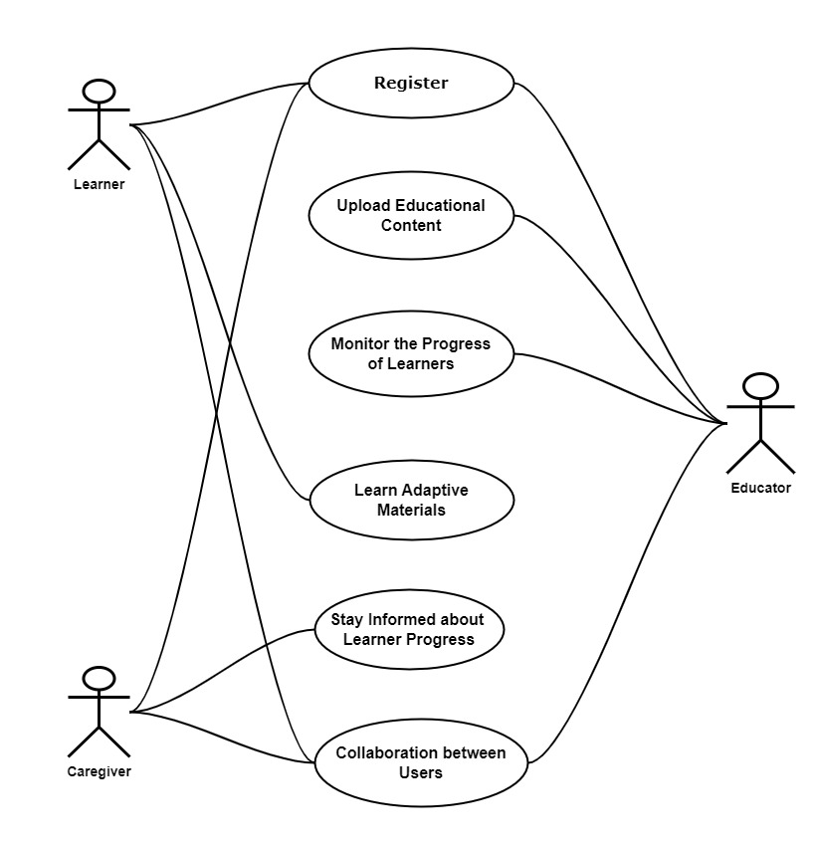

* Future Use Case (Figure 2)

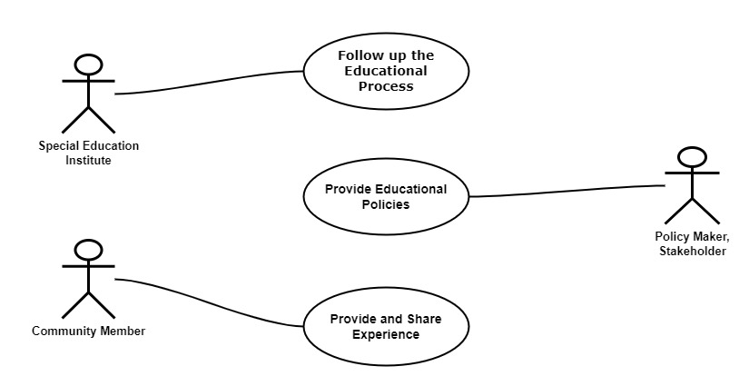

Use Case Description (Use case scenario)

* Main Use Case Diagram
* UC1 🡺 Register (Table 4)

|  |  |
| --- | --- |
| **Description** | The "**Register**" use case in the mobile application refers to the process of creating a user account with biometric logging on the literacy platform for individuals with special needs. This feature enhances security and accessibility by utilizing biometric data for user identification and authentication. |
| **Actors** | **User**: Individuals with special needs, educators, caregivers, or any other user creating an account on the mobile application. |
| **Preconditions** | 1. The mobile application is installed and accessible on the user's device.  2. The device supports biometric authentication (e.g., fingerprint or facial recognition). |
| **Postconditions** | 1. A user account is successfully created and linked to the user's biometric data.  2. The user gains access to personalized learning materials and platform features. |
| **Trigger** | The user launches the mobile application for the first time or selects the "**Register**" option within the application. |
| **User Story** | **As a User,**  **I want to** easily register on the literacy platform designed,  **So that** I can deal with the platform at any time. |
| **Acceptance Criteria** | 1. **Accessibility Compliance**: The registration process must adhere to accessibility standards to ensure compatibility with screen readers and other assistive technologies.  2. **Contrast and Readability**: Ensure high contrast and legible font choices to facilitate readability for learners with low vision.  3. **Alternative Input Methods**: Provide alternative input methods, such as keyboard shortcuts or voice commands, for filling in the registration details.  4. **Simplified Form Fields**: Minimize the number of mandatory fields and use clear, concise language to simplify the registration process for users with cognitive impairments.  5. **Error Handling**: Implement robust error handling with clear and descriptive messages to guide users in case of any input errors during registration.  6. **Customizable Preferences**: Allow users to set preferences for text size, color schemes, and other display options during the registration process to cater to individual needs. |

* UC2 🡺 Upload Educational Content (Table 5)

|  |  |
| --- | --- |
| **Description** | The "**Upload Educational Content**" use case enables educators to contribute educational materials to the literacy platform for individuals with special needs. This feature empowers educators to share tailored content that caters to the diverse learning needs of the platform's users. |
| **Actors** | **Educator:** A teacher or educational professional responsible for creating and uploading educational content. |
| **Preconditions** | 1. The educator has a registered account on the literacy platform.  2. The educator is logged into the platform through the mobile application. |
| **Postconditions** | 1. The educational content is successfully uploaded to the platform.  2. The content becomes accessible to learners based on their individualized learning paths. |
| **Trigger** | The educator initiates the "**Upload Educational Content**" action from within the mobile application. |
| **User Story** | **As an Educator,**  **I want to** be able to easily upload educational content to the Learn Adaptive Materials for Literacy platform  **So that** I can provide tailored and accessible materials to my students with special needs. |
| **Acceptance Criteria** | 1. The platform should offer a user-friendly content upload interface that supports a variety of file formats commonly used in educational materials (e.g., text, audio, Braille files).  2. I should be able to add detailed descriptions, metadata, and categorizations to each uploaded piece of content for easy search and identification.  3. The system should support batch uploads to streamline the process, allowing me to upload multiple resources in a single operation.  4. Content uploaded should undergo automatic accessibility checks to ensure compliance with standards and guidelines for materials designed for individuals with visual impairments.  5. There should be an option to preview the content before finalizing the upload, ensuring that the materials appear as intended and are suitable for learners with special needs.  6. The platform should provide clear guidelines and recommendations for creating accessible content to support educators in optimizing materials for learners with visual impairments.  7. Integration with third-party tools or platforms used by educators for content creation should be considered to facilitate a smooth and efficient upload process.  8. I want to receive notifications or updates on the status of my uploaded content, including any issues that may need attention or improvements for better accessibility.  9. The platform should include a feedback loop allowing educators to share insights on the effectiveness and usability of the content upload process. |

* UC3 🡺 Monitor the Progress of Learners (Table 6)

|  |  |
| --- | --- |
| **Description** | The "**Monitor the Progress of Learners**" use case enables educators to track and assess the academic progress of learners using the literacy platform for individuals with special needs. This feature provides valuable insights for educators to tailor their teaching approaches and offer additional support as needed. |
| **Actors** | **Educator:** A teacher or educational professional responsible for creating and uploading educational content. |
| **Preconditions** | 1. The educator has a registered account on the literacy platform.  2. The educator is logged into the platform through the mobile application.  3. Learners are actively engaged with the platform and have completed learning activities. |
| **Postconditions** | 1. The educator gains insights into the overall progress of learners.  2. Specific learner performance data, achievements, and challenges are accessible to the educator. |
| **Trigger** | The educator initiates the "**Monitor the Progress of Learners**" action from within the mobile application. |
| **User Story** | **As an Educator,**  **I want to** efficiently monitor the progress of my students on the Learn Adaptive Materials for Literacy platform  **So that** I can provide targeted support, adapt teaching strategies, and ensure personalized learning experiences. |
| **Acceptance Criteria** | 1. As an educator, I should have a dashboard displaying real-time progress data for each student with visual impairments enrolled in my class.  2. The dashboard should include metrics such as completion rates, time spent on tasks, and proficiency levels in various literacy skills.  3. The platform should generate detailed reports on individual student performance, highlighting strengths and areas needing improvement.  4. I want to receive notifications for significant milestones or challenges faced by students to facilitate timely intervention.  5. The progress tracking system should be compatible with screen readers and other assistive technologies, ensuring accessibility for educators with visual impairments.  6. The platform should allow me to customize goals and benchmarks for individual students based on their unique learning needs.  7. I should be able to access historical data to track the longitudinal progress of students and identify trends or patterns.  8. The platform should integrate with existing educational management systems or tools commonly used by educators for a seamless workflow.  9. I want the ability to communicate directly with students through the platform to provide feedback, encouragement, and additional guidance.  10. The progress monitoring feature should comply with data privacy regulations and ensure the confidentiality of student information. |

* UC4 🡺 Learn Adaptive Materials (Table 7)

|  |  |
| --- | --- |
| **Description** | The "**Learn Adaptive Materials**" use case enables learners to engage with adaptive learning materials on the literacy platform for individuals with special needs. This feature tailors educational content to the unique learning needs of each individual, promoting a personalized and effective learning experience. |
| **Actors** | **Learner:** Individuals with special needs actively engaging with the literacy platform for learning. |
| **Preconditions** | 1. The learner has a registered account on the literacy platform.  2. The learner is logged into the platform through the mobile application. |
| **Postconditions** | 1. The learner completes learning activities, quizzes, or interactive exercises.  2. The platform adapts subsequent materials based on the learner's performance and preferences. |
| **Trigger** | The learner initiates the "**Learn Adaptive Materials**" action by accessing the platform's learning resources. |
| **User Story** | **As a Learner,**  **I want to** access adaptive materials on the Learn Adaptive Materials for Literacy platform  **So that** I can enhance my literacy skills through specialized content tailored to my needs. |
| **Acceptance Criteria** | 1- As a user, I should be able to navigate the platform using screen reader software for a seamless experience.  2-The platform should provide options for customizing text size and contrast to accommodate varying visual preferences.  3-I want the platform to support multiple languages and offer content in Braille to cater to diverse learners.  4-The adaptive materials should include interactive Braille lessons, audio descriptions, and tactile elements for a comprehensive learning experience.  5-The platform should feature an easy-to-use interface with intuitive navigation, ensuring a user-friendly experience for individuals with visual impairments.  6-Progress tracking tools should be available to monitor my learning journey and identify areas for improvement.  7-The platform should offer a feedback mechanism, allowing me to provide input on the effectiveness of adaptive materials and suggest improvements.  8-Compatibility with Braille displays and other assistive technologies should be ensured for a seamless integration into my existing tools.  9-Regular updates and additions to the adaptive materials library should be part of the platform's commitment to continuous improvement.  10-The platform should be designed in compliance with accessibility standards to ensure a universally accessible and inclusive learning environment. |

* UC5 🡺 Stay Informed about Learner Progress (Table 8)

|  |  |
| --- | --- |
| **Description** | The "**Stay Informed about Learner Progress**" use case enables caregivers to monitor and stay informed about the academic progress of individuals with special needs using the literacy platform. This feature provides caregivers with insights into the learner's engagement, achievements, and areas for additional support. |
| **Actors** | **Caregiver:** Guardians or family members responsible for the well-being and educational support of learners with special needs. |
| **Preconditions** | 1. The caregiver has a registered account on the literacy platform.  2. The learner, for whom the caregiver is responsible, has an active account on the platform. |
| **Postconditions** | 1. The caregiver gains access to learner progress reports, achievements, and engagement metrics.  2. The caregiver stays informed about the learner's overall educational experience on the platform. |
| **Trigger** | The caregiver initiates the "**Stay Informed about Learner Progress**" action by accessing the learner's progress within the mobile application. |
| **User Story** | **As a Caregiver**  **I want to** be informed about the progress of the learner on the Literacy platform  **So that** I can provide appropriate support, track milestones, and ensure a tailored learning experience. |
| **Acceptance Criteria** | 1. The platform should provide a caregiver dashboard displaying an overview of the learner's achievements, challenges, and overall progress.  2. I want to receive regular notifications or updates regarding the learner's completed activities, achievements, and any areas that may require additional attention.  3. The platform should allow me to view detailed reports on the learner's performance, including completed lessons, time spent on tasks, and areas of improvement.  4. Progress reports should be accessible using screen readers and other assistive technologies to ensure inclusivity for caregivers with visual impairments.  5. The platform should offer insights into the effectiveness of adaptive materials and the learner's engagement with different types of content.  6. I want the ability to communicate with educators and instructors through the platform to discuss the learner's progress and address any concerns or questions.  7. The caregiver dashboard should be easy to navigate, with clear and intuitive design elements to enhance usability.  8. If the learner is facing challenges or requires additional assistance, the platform should provide guidance or suggestions for supportive interventions.  9. The system should respect and protect the privacy of the learner and adhere to relevant data protection regulations.  10. Regular feedback mechanisms should be in place to gather input from caregivers on the platform's usability and the relevance of progress reports. |

* UC6 🡺 Collaboration between Educators and Caregivers (Table 9)

|  |  |
| --- | --- |
| **Description** | The "**Collaboration between Educators and Caregivers**" use case facilitates communication and collaboration between educators and caregivers to ensure a coordinated approach to supporting the educational journey of learners with special needs on the literacy platform. |
| **Actors** | **1. Educator:** Teachers or educational professionals responsible for instructing learners.  **2. Caregiver:** Guardians or family members providing support and care for learners with special needs. |
| **Preconditions** | 1. Both the educator and caregiver have registered accounts on the literacy platform.  2. The learner, for whom the caregiver is responsible, is actively engaged on the platform. |
| **Postconditions** | 1. Educators and caregivers can exchange information, discuss learner progress, and collaborate on educational strategies.  2. Both educators and caregivers gain a comprehensive understanding of the learner's academic achievements, challenges, and personalized learning plan. |
| **Trigger** | Either the educator or the caregiver initiates the "**Collaboration between Educators and Caregivers**" action by accessing communication features within the mobile application. |
| **User Story** | **As an Educator and Caregiver,**  **I want** the ability to collaborate between each other through the Literacy Platform  **So that** we can ensure a coordinated and effective support system for the students with special needs. |
| **Acceptance Criteria** | 1. The platform should provide a secure and accessible space for educators and caregivers to collaborate on individual student profiles.  2. Educators and caregivers should be able to share information, progress updates, and insights regarding the student's literacy development on the platform.  3. The system should support real-time communication features such as messaging or discussion forums to facilitate ongoing collaboration between educators and caregivers.  4. There should be an option for educators to provide caregivers with access to specific learning resources, strategies, and materials used in the classroom.  5. The platform should allow educators to communicate specific learning goals, milestones, and areas of improvement to caregivers, ensuring alignment in support strategies.  6. Caregivers should have the ability to provide feedback on the student's learning experience and share observations from outside the classroom environment.  7. Accessibility features must be integrated into the collaboration tools to accommodate caregivers with visual impairments or other disabilities. |

* Future Use Case Diagram
* UC7 🡺 Follow Up the Educational Process (Table 10)

|  |  |
| --- | --- |
| **Description** | The "**Follow Up the Educational Process**" use case allows Special Education Institutes to monitor and follow up on the educational process of learners within their programs using the literacy platform. This feature provides institutes with insights into overall progress, effectiveness of interventions, and areas for further support. |
| **Actors** | **Special Education Institute**: Educational institutions specializing in providing special education services. |
| **Preconditions** | 1. The special education institute has a registered account and administrative access on the literacy platform.  2. Learners associated with the institute are actively engaged in learning activities on the platform. |
| **Postconditions** | 1. The special education institute gains access to aggregated reports on learner progress, engagement, and overall performance.  2. The institute can identify trends, areas of improvement, and assess the impact of special education interventions. |
| **Trigger** | The special education institute initiates the "**Follow Up the Educational Process**" action by accessing administrative features within the mobile application. |
| **User Story** | **As a Special Education Institute,**  **I want** to ensure a streamlined and personalized follow-up process for the educational journey of individuals with special needs on our literacy platform,  **So that** we can track their progress, identify areas of improvement, and provide targeted support for their unique learning requirements. |

* UC8 🡺 Provide Educational Policies (Table 11)

|  |  |
| --- | --- |
| **Description** | The "**Provide Educational Policies**" use case enables Policy Makers or Stakeholders to contribute educational policies, guidelines, and standards to the literacy platform for individuals with special needs. This feature ensures that the platform aligns with broader educational objectives and inclusivity standards. |
| **Actors** | **Policy Maker or Stakeholder:** Individuals involved in formulating educational policies, guidelines, or standards. |
| **Preconditions** | 1. The policy maker or stakeholder has a registered account and administrative access on the literacy platform.  2. The literacy platform actively seeks and encourages contributions from policy makers or stakeholders. |
| **Postconditions** | 1. Educational policies and guidelines are successfully submitted to the platform.  2. The provided policies are reviewed, then they become part of the platform's framework for inclusivity and education. |
| **Trigger** | The policy maker or stakeholder initiates the "**Provide Educational Policies**" action by accessing administrative features within the mobile application. |
| **User Story** | **As a Policy Maker and Stakeholder**,  **I want to** implement a feature that provides specialized educational policies on the literacy platform, catering specifically to individuals with special needs. This initiative aims to ensure inclusivity and accessibility in education, addressing the diverse learning requirements of this unique demographic |

* UC9 🡺 Provide and Share Experience (Table 12)

|  |  |
| --- | --- |
| **Description** | The "**Provide and Share Experience**" use case empowers community members to actively contribute their experiences, insights, and feedback within the literacy platform for individuals with special needs. This feature fosters a supportive community environment and facilitates the exchange of valuable information. |
| **Actors** | **Community Members:** Users who actively participate in community engagement forums associated with the literacy platform. |
| **Preconditions** | 1. Community members have registered accounts on the literacy platform.  2. The platform actively encourages and provides features for community engagement and sharing experiences. |
| **Postconditions** | 1. Community members successfully share their experiences, insights, or feedback within the platform.  2. Shared content contributes to the collective knowledge and support network within the literacy platform community. |
| **Trigger** | The community member initiates the "**Provide and Share Experience**" action by accessing community engagement features within the mobile application. |
| **User Story** | **As a Community Member** on the literacy platform dedicated to supporting individuals with special needs,  **I want to** be able to provide and share my unique experiences to inspire and encourage others in the community. |

System Architecture (Figure 3)

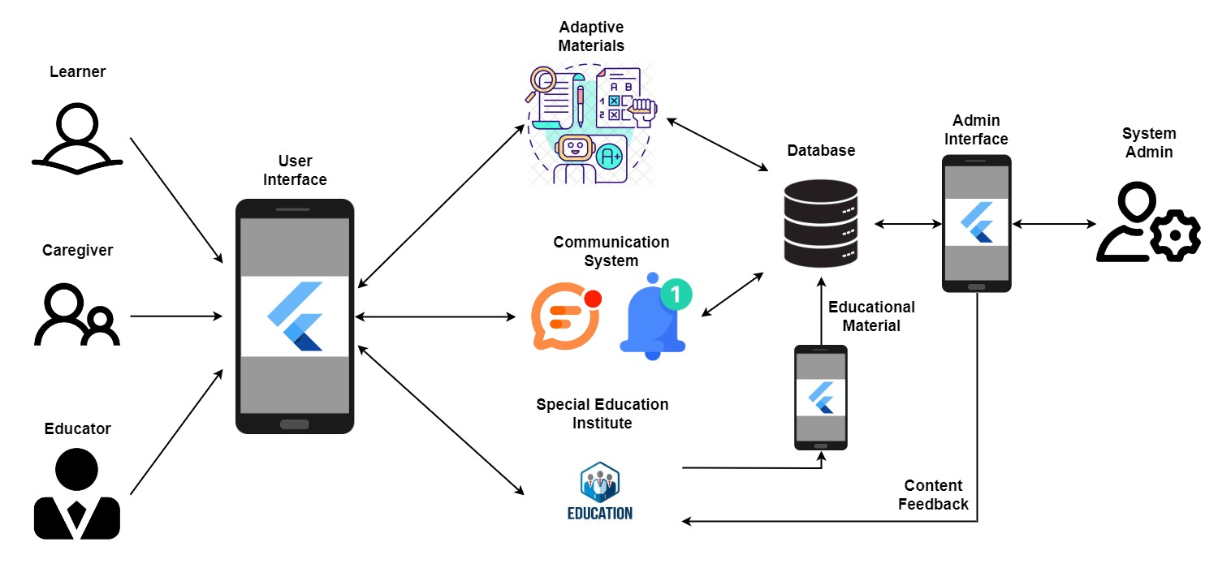

Analysis Class

* State Diagram (Figure 4-6)
* Register State Diagram (Figure 4)

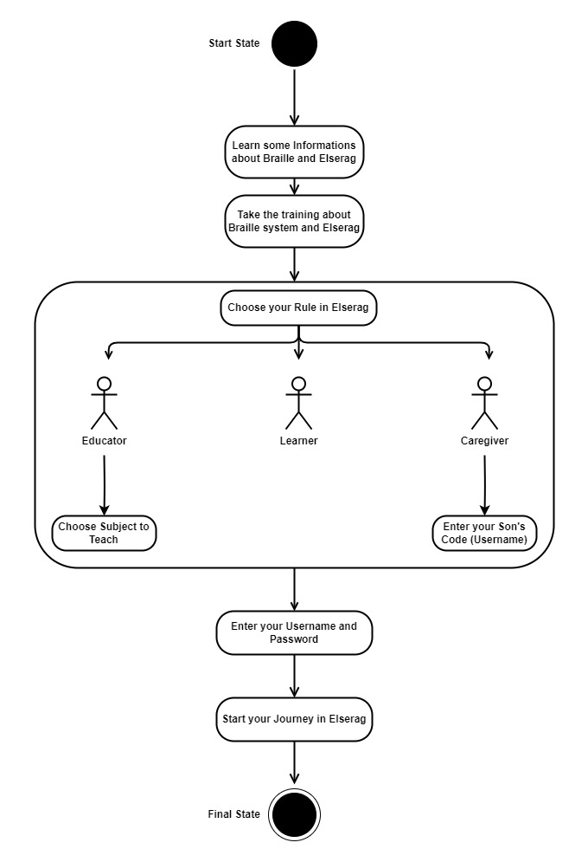

* Learner State Diagram (Figure 5)

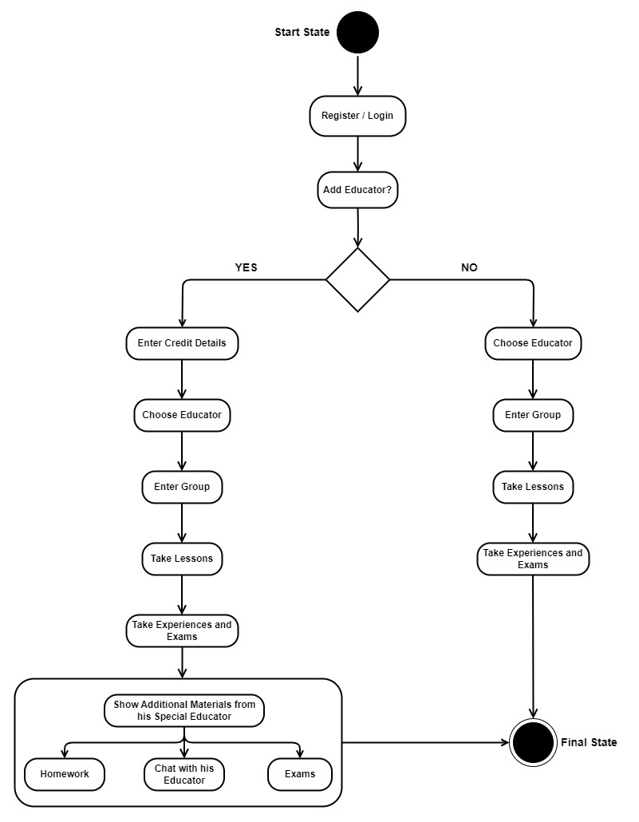

* Caregiver and Educator State Diagram (Figure 6)

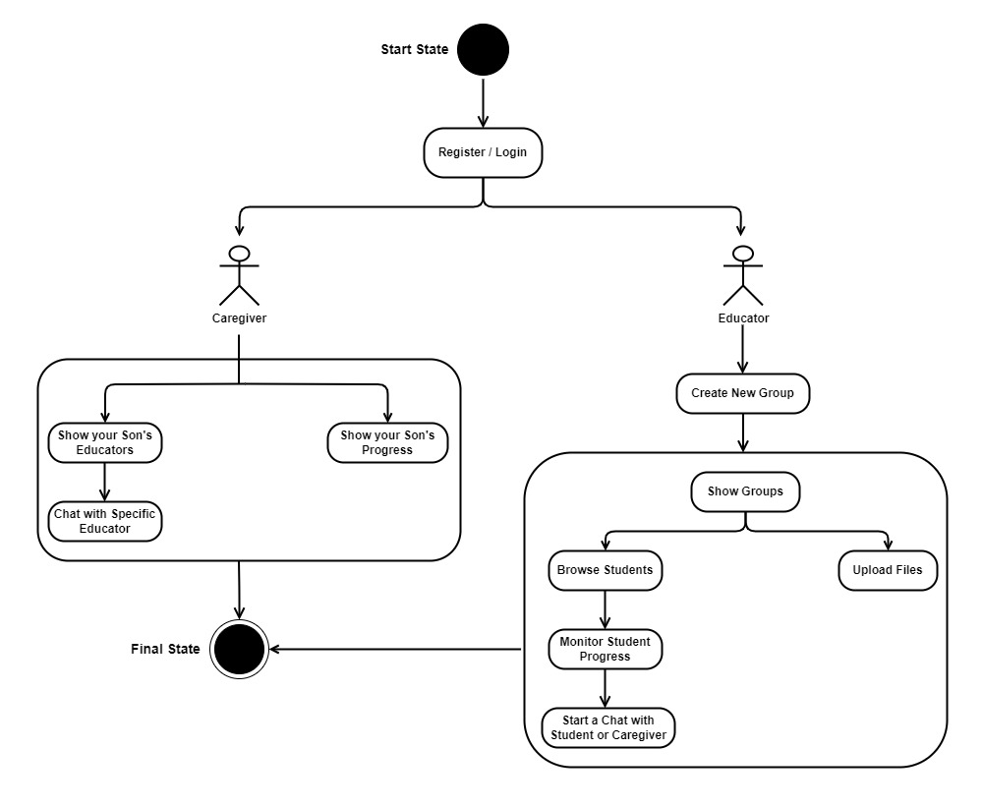

* Data flow diagram (Level Zero diagram) (Figure 7)

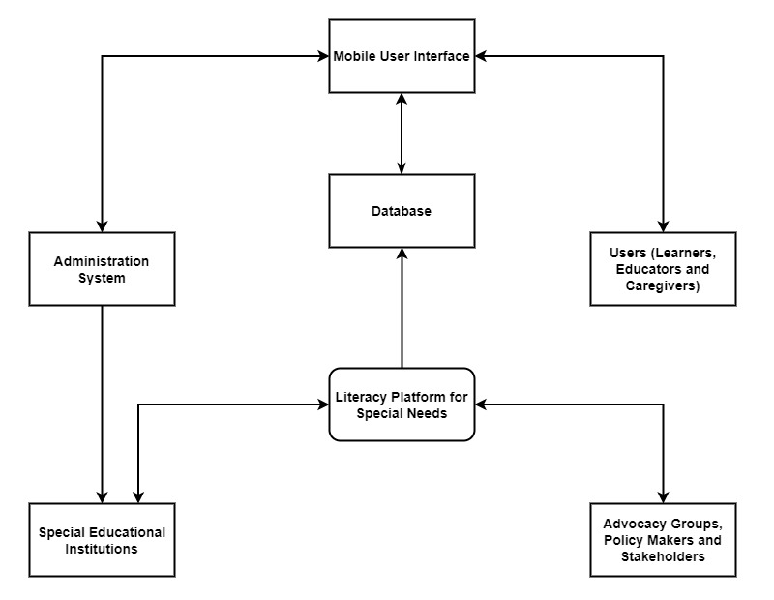

* Context Diagram (Figure 8)

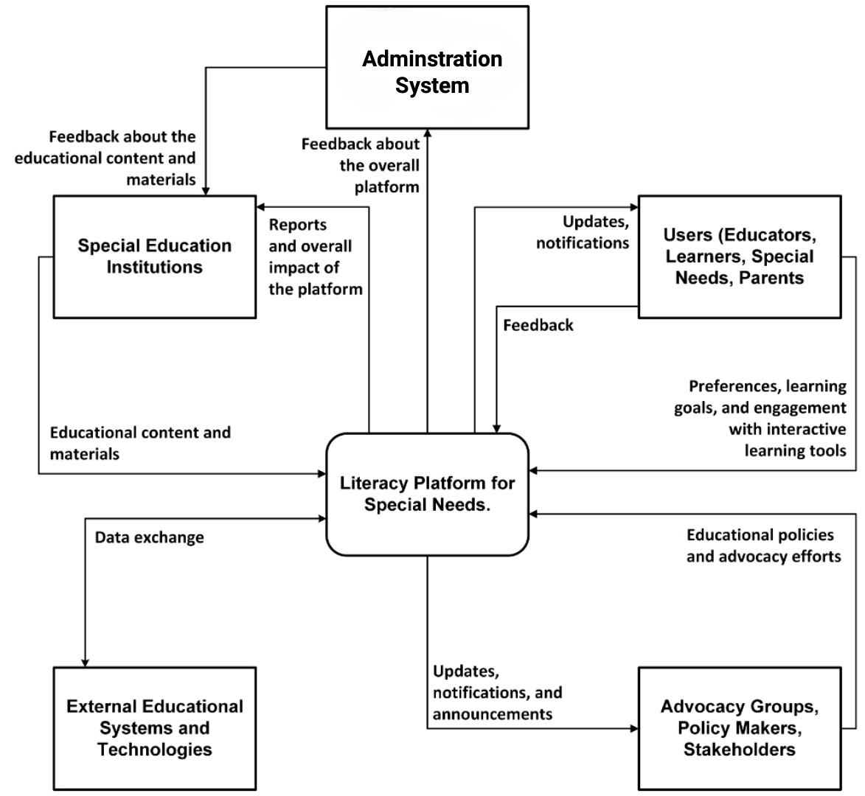

Interaction Class Diagram

* Sequence Diagram (Figure 9-12)
* Log In Sequence Diagram (Figure 9)

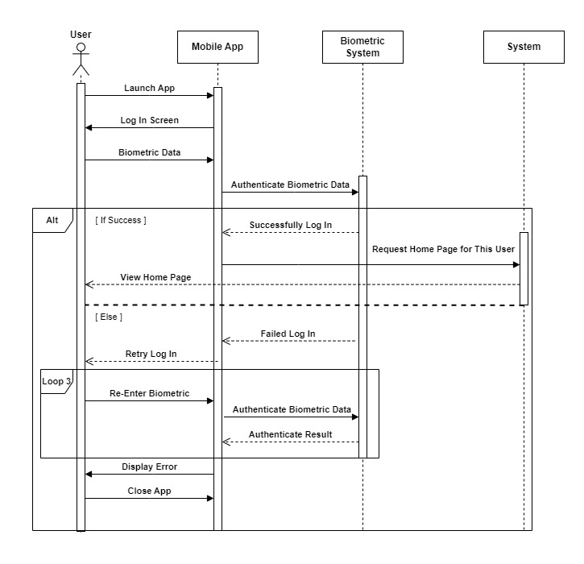

* Uploading and Monitoring Sequence Diagram (Figure 10)

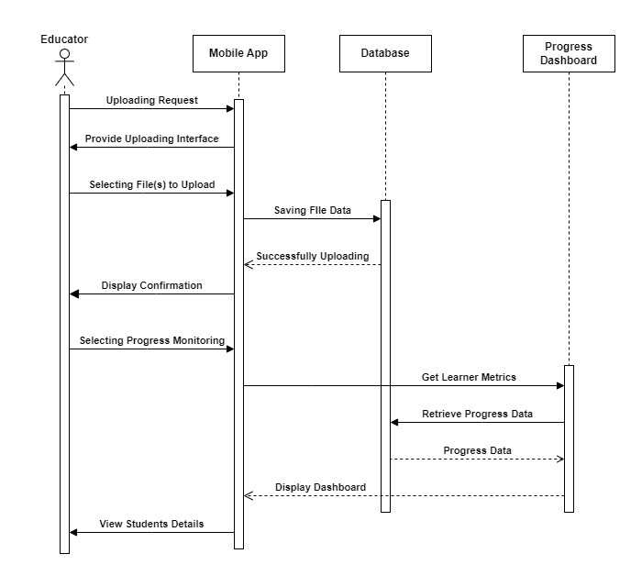

* Learning Sequence Diagram (Figure 11)

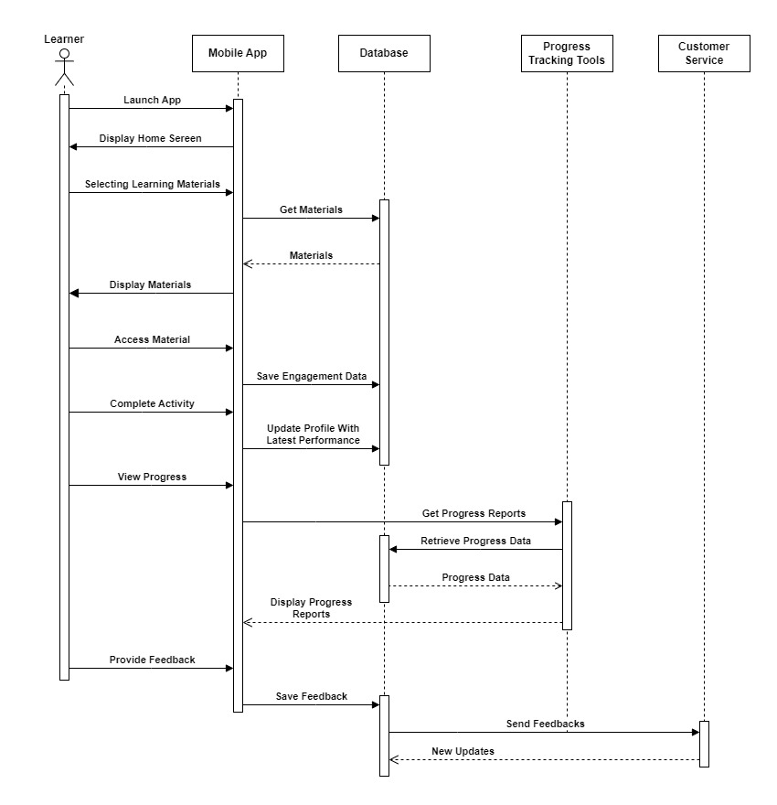

* Stay Informed and Collaboration Sequence Diagram (Figure 12)

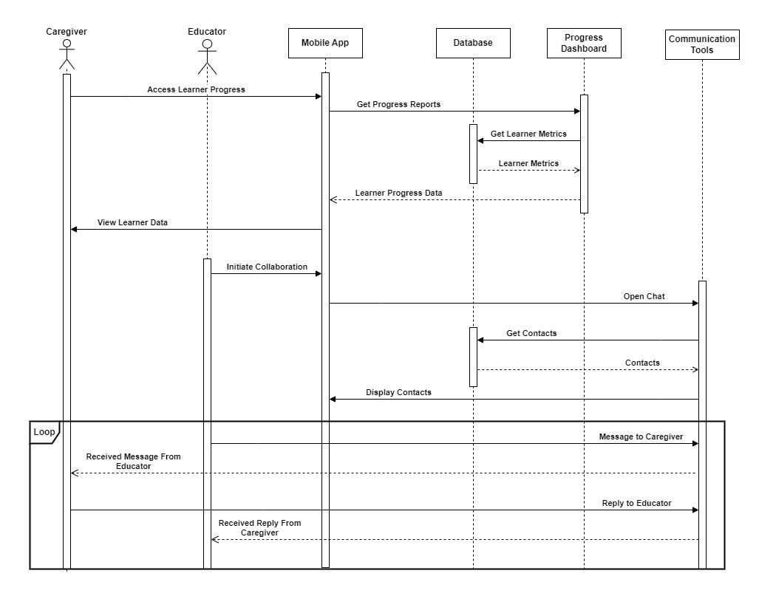

Design Class (Figure 13)

* Class Diagram

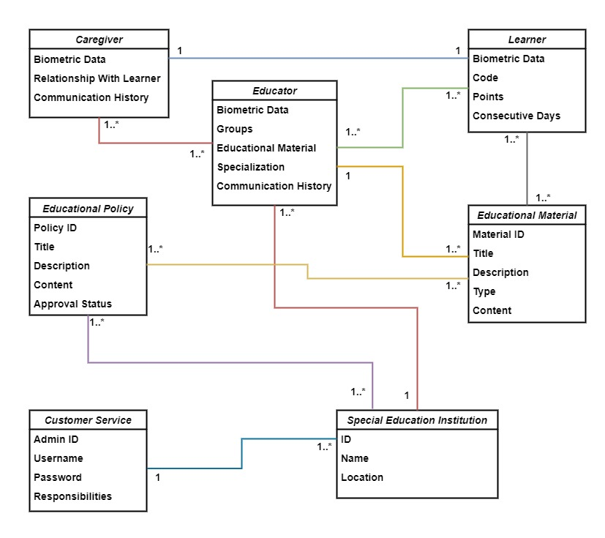

Database Schema (Figure 14)

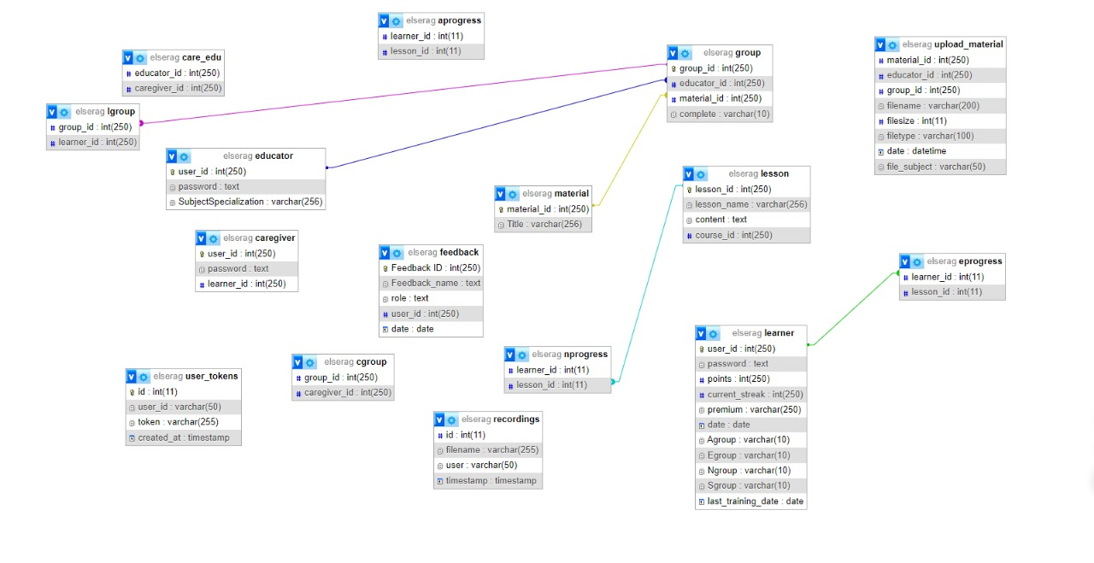

ER Diagram (Figure 15)

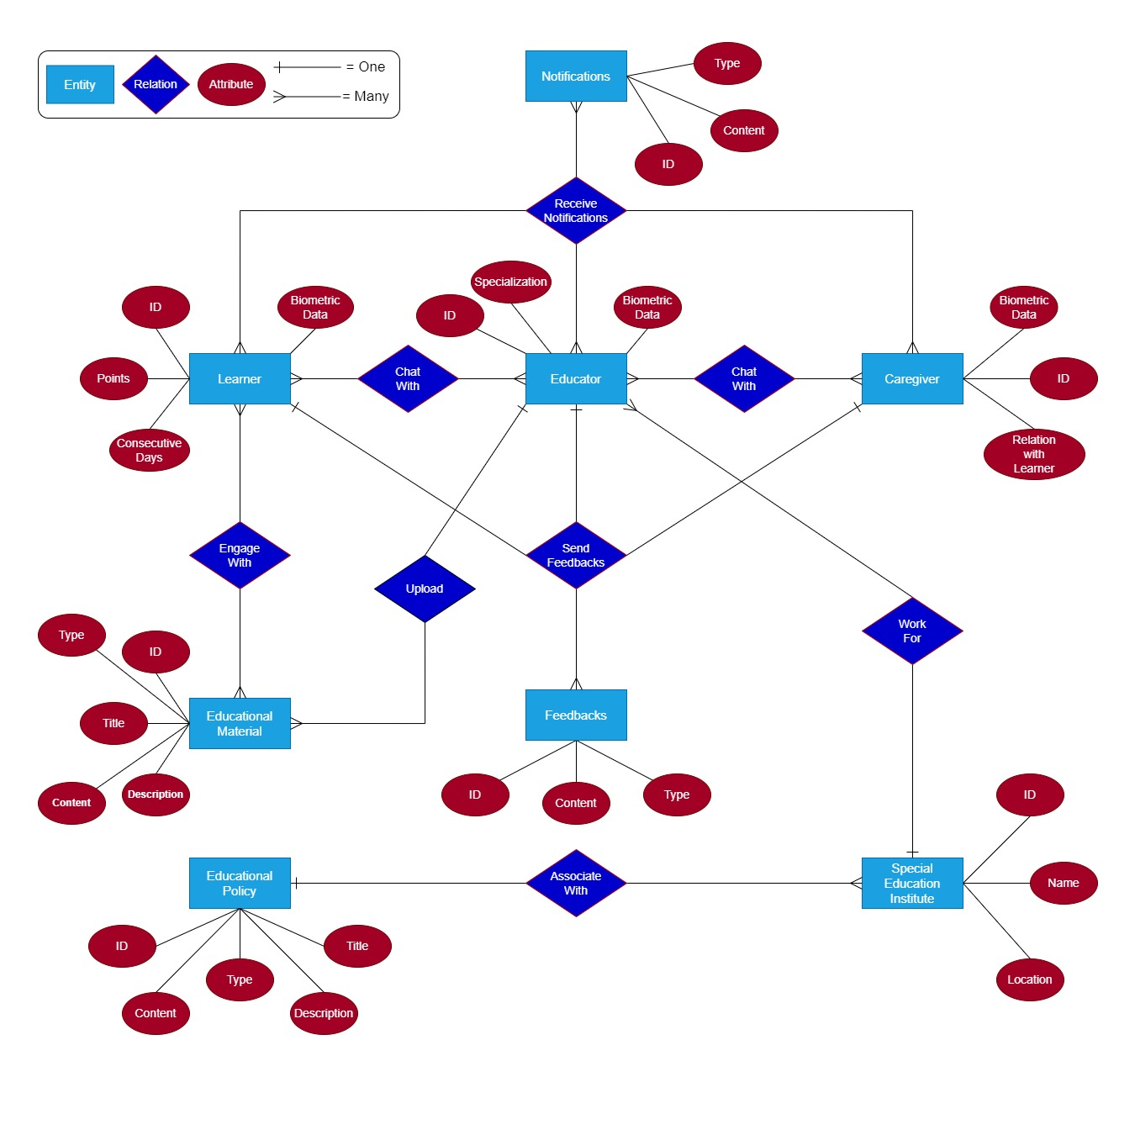

**Chapter 5**

**Implementation & Testing**

Programming languages and Frameworks

* Front-End Part
* Flutter
* Dart
* Shared preferences
* Back-End Part
* PHP
* MySQL
* Stripe
* JWT

Algorithms

* Hash algorithm for passwords.
* Text to Speech
  + **Step 1: Add Dependencies**
    - **Open** pubspec.yaml file.
    - **Add** the following line under dependencies:
      * flutter_tts: ^3.1.0----code
    - **Run** flutter pub get to install the package.
  + **Step 2: Import the Package**
    - **Open** the Dart file where you want to implement TTS (e.g., main.dart).
    - **Add** the following import statement at the top:
      * **import 'package:flutter_tts/flutter_tts.dart';**
  + **Step 3: Initialize and Configure the TTS Engine**
    - **Create** a class or method to initialize FlutterTts.
    - **Instantiate** FlutterTts:
      * **FlutterTts flutterTts = FlutterTts();----code**
    - **Set** language, pitch, and speech rate (optional)
  + **Step 4: Create a Flutter Widget to Use TTS**
    - **Define** a StatefulWidget to manage TTS state.
    - **Create** a TextField to capture user input.
    - **Create** buttons for speaking and stopping the TTS.
    - **Implement** methods to handle speaking and stopping
  + **Step 5: Configure Platform-Specific Settings**
    - **For iOS**:
      * **Open** ios/Runner/Info.plist.
      * **Add** the following permissions:
      * **code**
      * <key>NSMicrophoneUsageDescription</key>
      * <string>We need your microphone to give you a voice</string>
      * <key>NSSpeechRecognitionUsageDescription</key>
      * <string>We need your permission to use speech recognition</string>
    - **For Android**:
      * **Open** android/app/src/main/AndroidManifest.xml.
      * **Ensure** the following permission is included:
        + Code:
        + <uses-permission android:name = "android.permission.INTERNET"/>

Application Essentials

* Front-End Implementation (Figure 16-21)
  + Courses 🡺 (Figure 16-19)

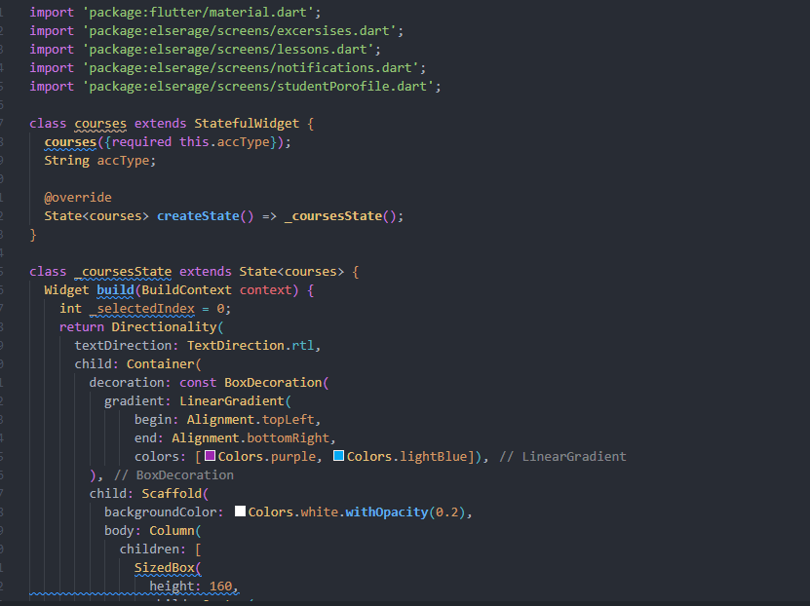

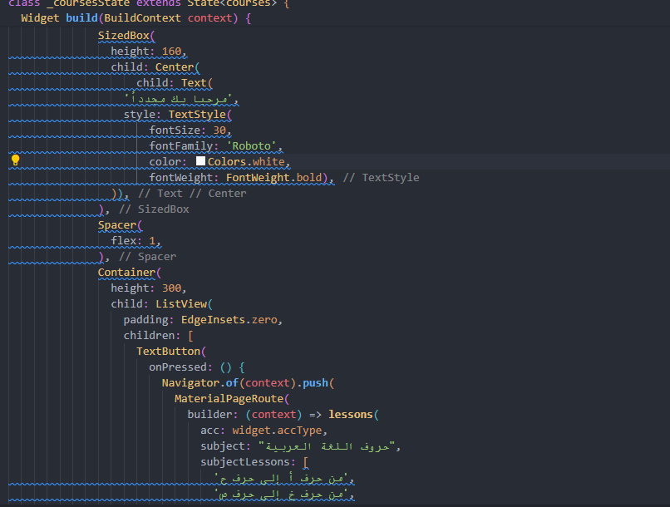

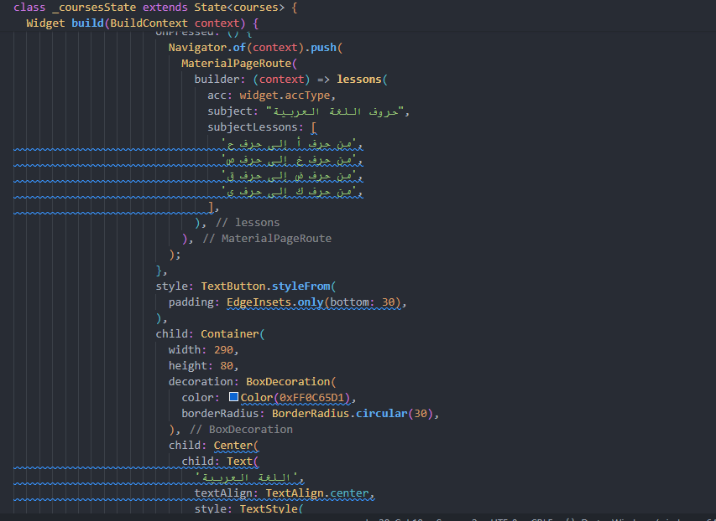

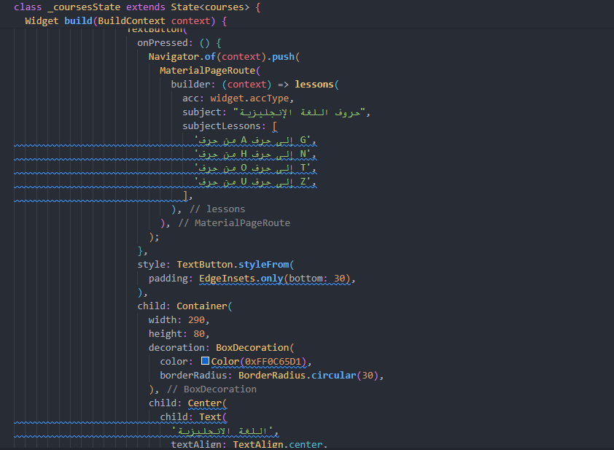

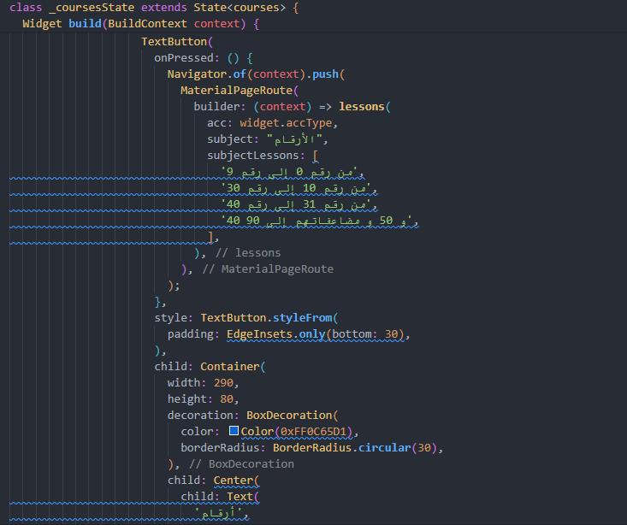

* + Lessons 🡺 (Figure 20)

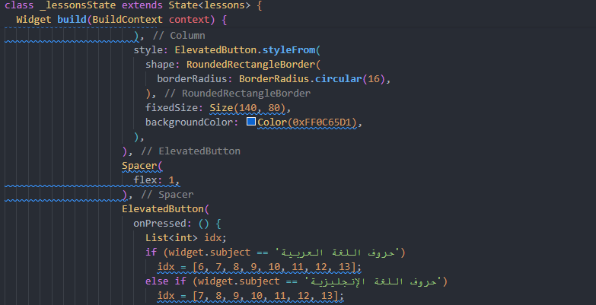

* + Exercises 🡺 (Figure 21)

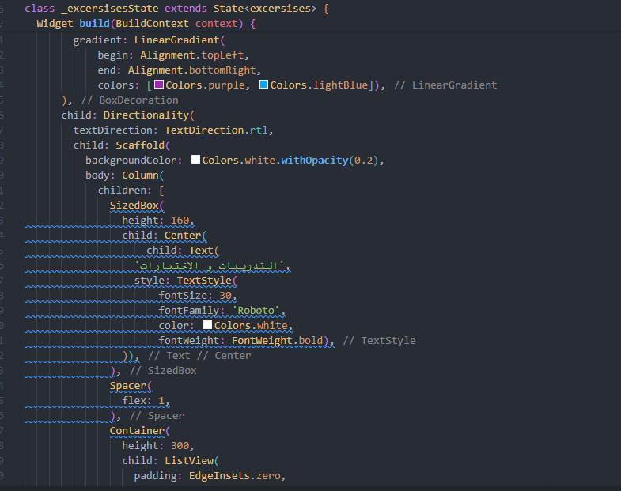

* Back-End Implementation (Figure 22-30)
  + **Backend Framework and Language**: We have chosen PHP and MySQL for database.
  + **Database Management**: MySQL is used to manage our application's relational database. The database schema includes tables for users, etc., ensuring efficient data storage and retrieval.
  + **API Integration**: Stripe is integrated into our backend to handle payment transactions securely. This involves setting up Stripe API endpoints and ensuring PCI compliance for handling sensitive payment information.
  + **Authentication and Authorization**: JWT tokens are used for user authentication. Upon successful login, a JWT token is issued, which is then used to authenticate subsequent requests to protected API endpoints.
  + **Security Measures**: We implement input validation, encrypt sensitive data (e.g., passwords) stored in the database.
  + **Error Handling**: Robust error handling mechanisms ensure that appropriate error messages are returned to the frontend for any invalid requests or server-side issues.
  + **Documentation**: Detailed documentation of API endpoints, data models, and backend architecture is maintained to aid in future development and troubleshooting.

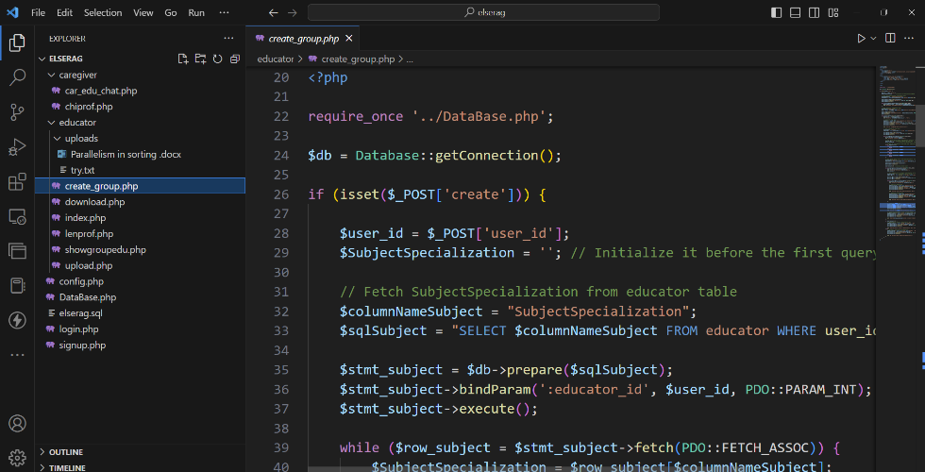

Testing Scenarios

* Front-End Testing (Table 4) (Figure 31-34)

|  |  |  |
| --- | --- | --- |
| Test Case Description | Test Data | Expected Result |
| During the login process, the student is told to enter a username that contains 6 characters | **Username** | **Successful login** |
| The student enter valid username characters | **Invalid username** | **Try again** |
| During the login process, the student is told to enter a password that contains 6 numbers | **Password** | **Successful login** |
| The student enter valid password numbers | **Invalid Password** | **Try again** |
| When a student tries to learn a lesson and enters a letter that matches the letter for the lesson | **Correct letter** | **Successful complete lesson and take points** |
| When a student tries to learn a lesson and enters a letter that don’t matches the letter for the lesson | **Invalid letter** | **Try again the lesson** |
| When the student tries to enter the credit card number into the payment system | **Correct credit card number** | **Successful process** |
| Enter invalid credit card number | **Invalid credit card number** | **Try again the process** |

* Lessons Testing 🡺

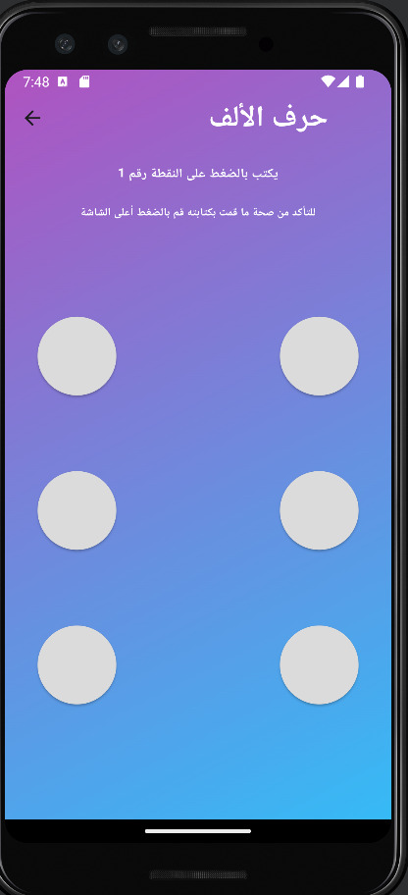

* Username Testing 🡺

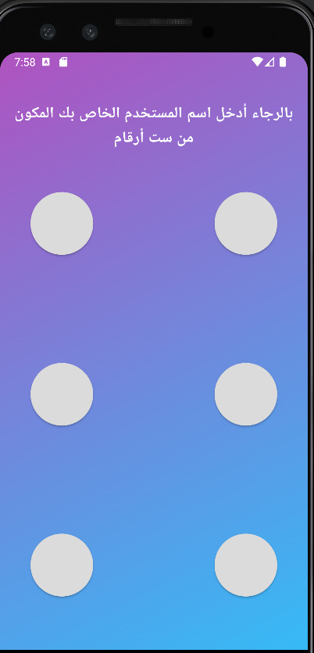

* Password Testing

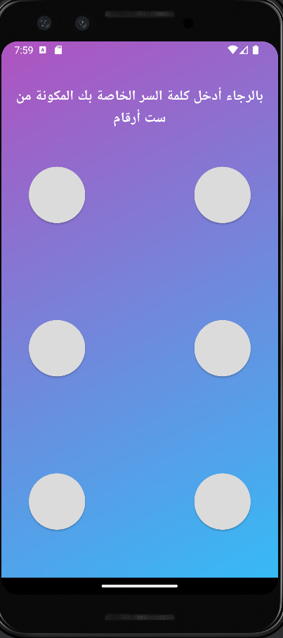

* Payment System Testing

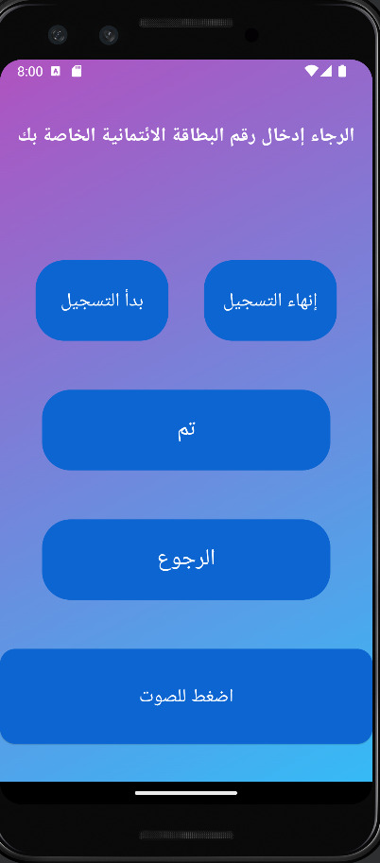

* Back-End Testing (Figures 35-38)

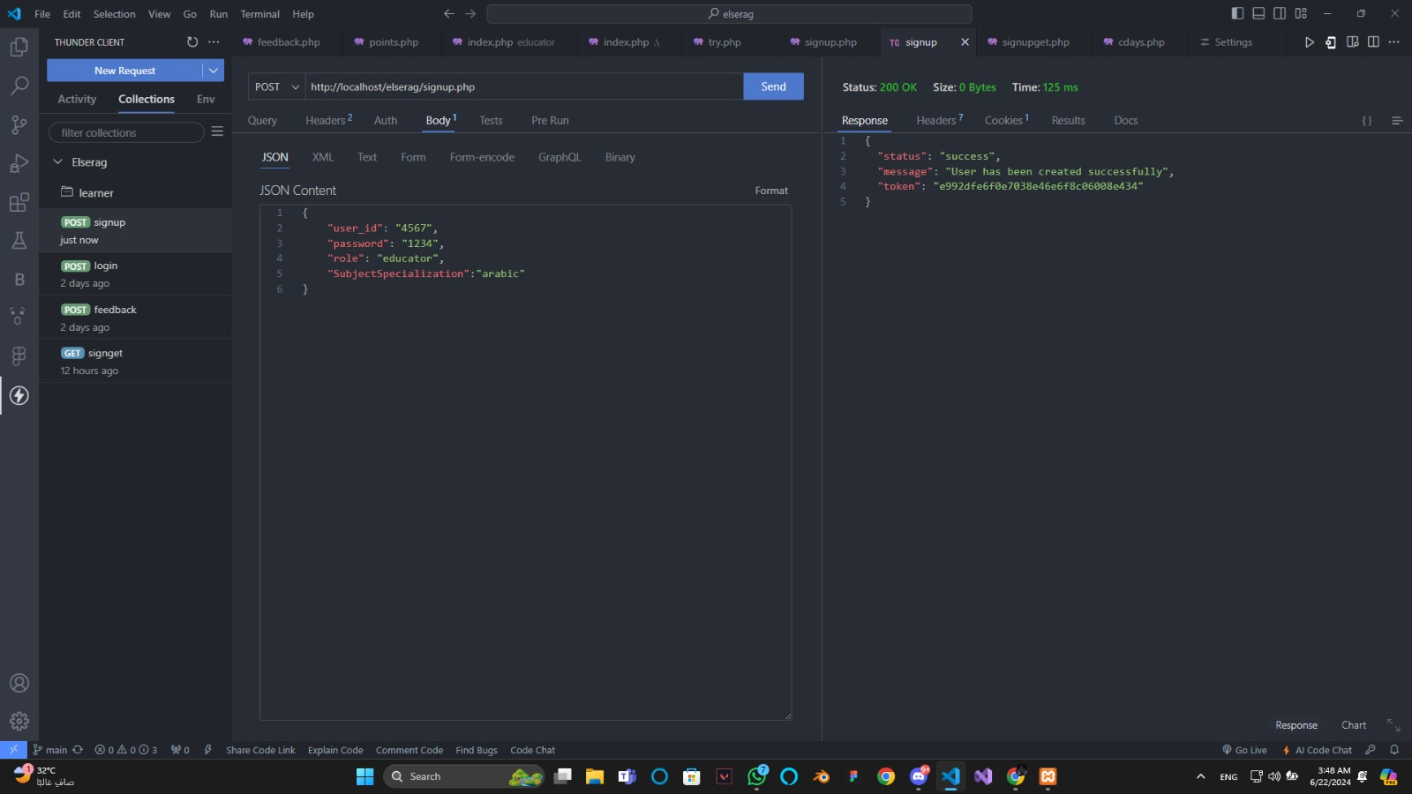

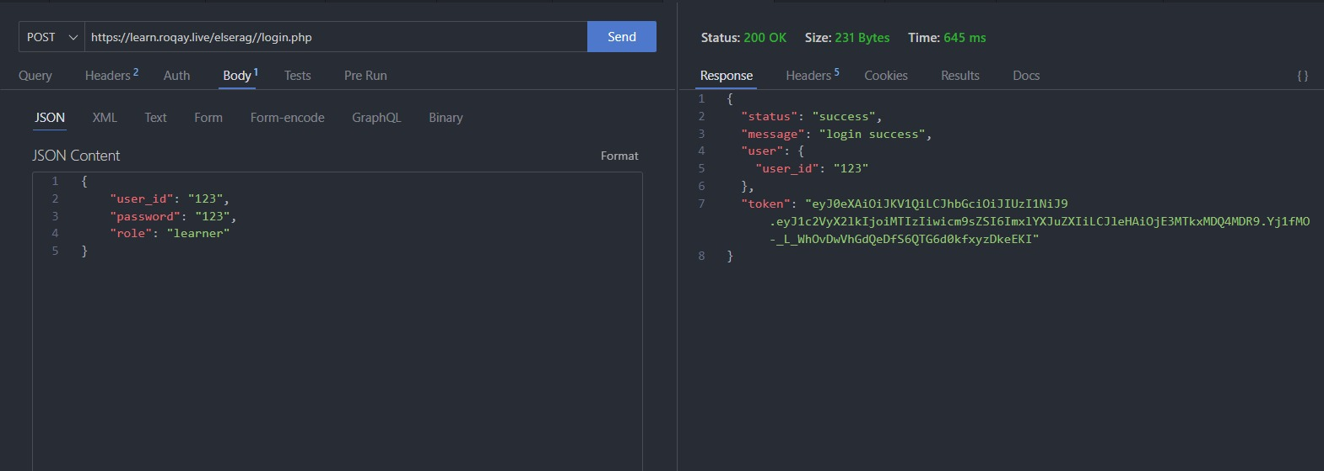

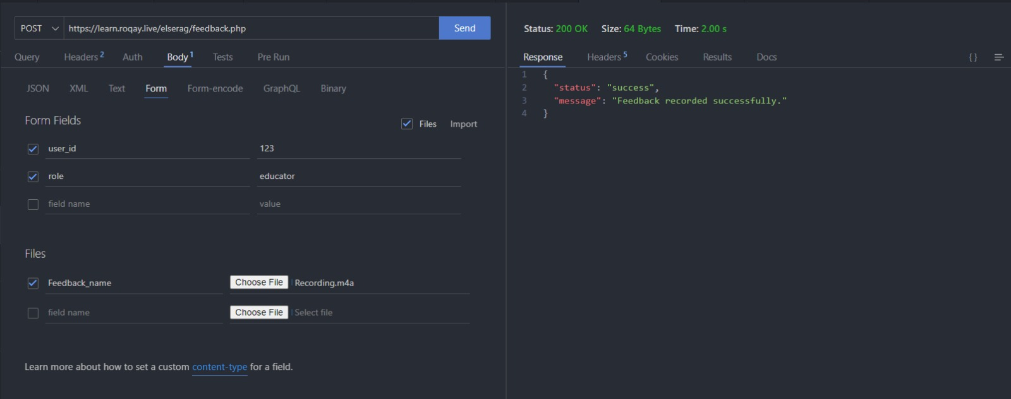

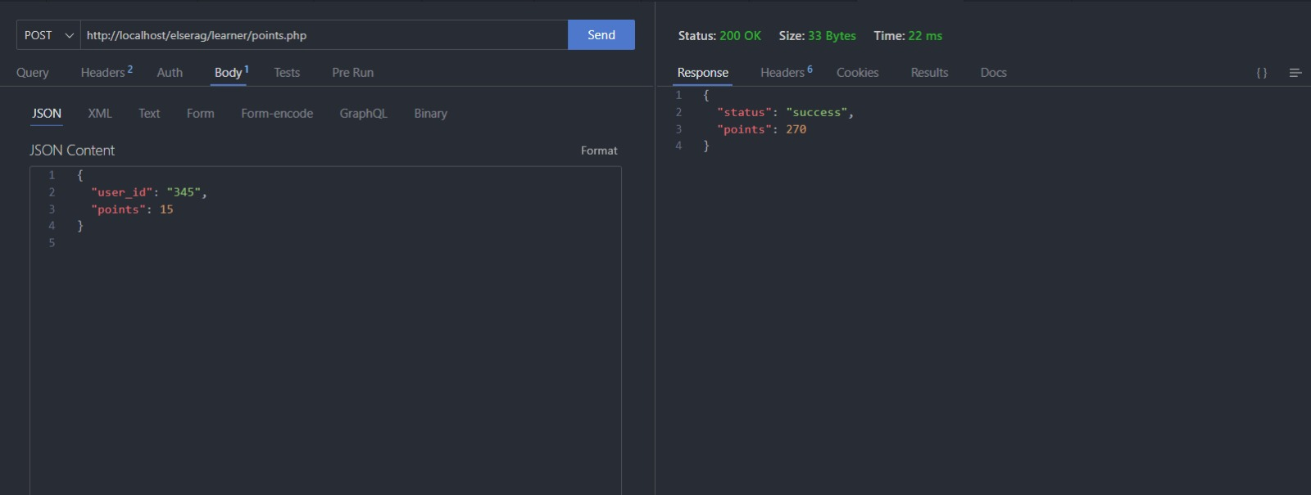

**Chapter 6**

**Evaluation & Results**

In this chapter we will mention some of our platform features and try as much as we can to evaluate it in an abstract manner.

First Feature 🡺 Braille System

The inclusion of Braille functionality within our mobile platform presents a fascinating opportunity to bridge the digital divide for visually impaired users. Let's delve into the potential benefits and considerations for this innovative feature.

**Empowering Literacy and Independence:**

* **Enhanced Access:** Braille support directly translates on-screen information into a tactile format, granting blind users independent access to the platform's content and functionalities.
* **Literacy Reinforcement:** By interacting with Braille representations, users can solidify their literacy skills and navigate the digital world with greater confidence.
* **Educational Equity:** Integrating Braille fosters inclusivity within the mobile learning landscape, ensuring blind users have equal access to educational resources.

**Usability and Considerations:**

* **Intuitive Design:** The Braille interface needs to be intuitive and seamlessly integrated with the platform's existing functionalities.
* **Learning Curve:** While Braille offers significant benefits, there might be a learning curve for users new to the system.
* **Device Compatibility:** Ensuring compatibility with various refreshable Braille displays and mobile devices is crucial for maximizing accessibility.

**Overall, integrating Braille functionality holds immense potential to empower blind users, fostering their independence and enriching their digital experience. By carefully considering the usability aspects and providing proper learning resources, this feature can become a powerful tool for bridging the digital divide and promoting inclusivity within the mobile world.**

Second Feature 🡺 Screen Readers

Our mobile platform's support for screen readers marks a significant step towards creating a more inclusive digital environment for users who are blind or visually impaired. Here's an analysis of the potential and considerations surrounding this crucial feature.

**Expanding Accessibility:**

* **Unlocking Information:** Screen reader integration transforms on-screen text and elements into an audible format, allowing blind users to access and interact with the platform's functionalities.
* **Empowering Navigation:** Screen readers empower users to navigate the platform independently, fostering a sense of autonomy and control over their mobile experience.
* **Breaking Barriers:** This feature dismantles a significant barrier to information access, allowing blind users to participate more actively in the digital world.

**Optimizing the User Experience:**

* **Seamless Integration:** The screen reader experience needs to be seamless, to ensure that the user becomes part of the system.
* **Intuition Reigns Supreme:** The platform's design itself should be intuitive, with clear and well-structured information hierarchies to enhance the screen reader experience.

**Overall, screen reader integration represents a cornerstone of accessibility within our mobile platform. It empowers blind users to navigate, access information, and engage with the platform's offerings, fostering a more inclusive digital environment. By prioritizing seamless integration, compatibility, and intuitive design, we can ensure screen readers unlock the full potential of the platform for visually impaired users.**

Third Feature 🡺 Variety of Users

Our mobile platform's ability to cater to a variety of users, including learners, educators, and caregivers, creates a beautiful symphony of roles within the learning ecosystem. Let's explore the unique value this feature brings to each group.

**Learners Take Center Stage:**

* **Personalized Learning:** Learners can use the platform to their individual needs and learning styles, maximizing their educational journey.
* **Engaged Participation:** The platform fosters active participation through interactive features, empowering learners to take ownership of their education.
* **Seamless Access:** Learners enjoy the convenience of accessing educational resources and connecting with educators and caregivers anytime, anywhere.

**Educators Conduct the Orchestra:**

* **Differentiated Instruction:** Educators can leverage the platform to create differentiated learning experiences that cater to diverse student needs.
* **Enhanced Assessment:** The platform provides educators with tools to track learner progress and provide feedback in a timely and efficient manner.
* **Streamlined Communication:** Educators can connect with learners and caregivers seamlessly, fostering a collaborative learning environment.

**Caregivers Become Supporting Instruments:**

* **Monitoring Progress:** Caregivers can monitor learner progress on the platform, gaining valuable insights into their learning journey.
* **Active Collaboration:** Caregivers can collaborate with educators by providing feedback and fostering learning activities at home.

**In essence, the platform's ability to support a variety of users fosters a collaborative and inclusive learning environment. Learners take center stage in their educational journey, guided by the expertise of educators and supported by the active involvement of caregivers. This symphony of roles creates a powerful force for maximizing learning potential.**

Fourth Feature 🡺 Communication between Different Types of Users

Our mobile platform's ability to facilitate communication between learners, educators, and caregivers fosters a dynamic learning ecosystem. Let's delve into the power of this feature and its impact on various stakeholders.

**Building Bridges of Understanding:**

* **Enhanced Collaboration:** Open communication channels allow educators, learners, and caregivers to collaborate effectively, setting goals, addressing challenges, and celebrating successes.
* **Personalized Support:** Learners can receive immediate support and clarification from educators, fostering a more personalized learning experience.
* **Empowered Caregivers:** Caregivers can stay informed about their loved ones' learning progress and collaborate with educators to provide well-rounded support.

**Optimizing Communication Flow:**

* **Variety of Tools:** The platform should offer a variety of communication tools like secure messaging, discussion forums, and video conferencing to cater to different communication styles and needs.
* **Real-Time Interaction:** Enabling real-time interaction fosters a sense of community and allows for immediate feedback and support.
* **Privacy and Safety:** Robust security measures are essential to ensure the privacy and safety of all users during communication.

**Overall, the ability to facilitate communication between different user types within our mobile platform creates a dynamic learning environment. This fosters collaboration, personalized support, and a sense of community, ultimately leading to a more enriching and effective learning experience for all.**

Conclusion

As we said previously, our platform has many features to try, so we can’t mention all of them here and we will mention the previous features as an example of our awesome features, but if you want to know more about our platform and it’s features, The only way is to try it with yourself.

**Chapter 7**

**Conclusion & Feature work**

Conclusion

The envisioned **literacy platform** for individuals with special needs represents a transformative and inclusive initiative aimed at overcoming barriers to traditional education. By integrating **adaptive learning methodologies**, personalized pathways, and robust community support, the project seeks to empower **learners**, **educators**, **caregivers**, and **institutions** within the special education domain. The commitment to accessibility, inclusivity, and privacy, coupled with innovative features such as interactive tools and multilingual support, positions the platform as a pivotal resource for fostering personalized and enriching educational experiences.

Continuous refinement, stakeholder collaboration, and adherence to special education standards underscore the project's dedication to creating a dynamic and supportive ecosystem.

As this initiative unfolds, its potential to redefine **literacy education for individuals with special needs** becomes a beacon of hope for fostering **growth**, **communication**, and **societal integration** within this diverse community.

Future work

We have great aspirations for future work, we will mention some of them below:

1. Make the application **support multilingual**, to expand the scope of application use.
2. Add more **advanced information** in the existing tracks, to help the learner be stronger and in these tracks.
3. Support **more tracks and sciences** in the near future.
4. Apply the **scanner feature** in the application, to enable the user to scan any book or image to know what it contains by voice.
5. Add the **Administration System**, to track the user feedbacks on the overall platform and many other tasks.
6. **Sign Contracts with Special Education Institutions**, to follow the learning process and provide the platform with the Educators and Materials.

References

* Unified Modeling Languages (UML)
* **Microsoft Visio** ([https://www.microsoft.com/en-us/microsoft- 365/visio/flowchart-software](https://www.microsoft.com/en-us/microsoft-%20%20%20365/visio/flowchart-software))
* **Flowchart Maker** (<https://app.diagrams.net/>)
* User Interfaces and Experience (UI / UX)
* **Figma** (<https://www.figma.com/>)
* **Microsoft Bing for Image Creation** (<https://www.bing.com/images/create?FORM=GERRLP>)
* Information about Special Needs
* **Wikipedia** (<https://www.wikipedia.org/>)
* **Elnour School** (Aswan City)
* **Elnour and ElAml School** (Luxor City)
* Problem with Special Needs
* Egypt - Disability: IN. (n.d.): ([https://disabilityin.org/country/egypt/#:~:text=There%20are%2012%20million%20persons,the%20United%20Nations%20Development%20Programme.](https://disabilityin.org/country/egypt/%23:~:text=There%20are%2012%20million%20persons,the%20United%20Nations%20Development%20Programme.))
* The real lives behind the data: Children with disabilities in education across Egypt, Jordan, Lebanon and the occupied Palestinian territory (September 2022) - Egypt. (n.d.). ReliefWeb. (<https://reliefweb.int/report/egypt/real-lives-behind-data-children-disabilities-education-across-egypt-jordan-lebanon-and-occupied-palestinian-territory-september-2022>)
* (n.d.). Economic Research Forum (ERF). (<https://erf.org.eg/app/uploads/2018/09/1215.pdf>)
* (n.d.). ERIC - Education Resources Information Center. (<https://files.eric.ed.gov/fulltext/EJ1300085.pdf>)
* A national screening for the prevalence and profile of disability types among Egyptian children aged 6-12 years: a community-based population study - PubMed. (n.d.). PubMed. ([https://pubmed.ncbi.nlm.nih.gov/37608272/#:~:text=Results:%20The%20prevalence%20of%20children,,%20and%20hearing%20(0.4%](https://pubmed.ncbi.nlm.nih.gov/37608272/%23:~:text=Results:%20The%20prevalence%20of%20children,,%20and%20hearing%20(0.4%25))
* Blind community in Egypt. (n.d.). MOSTAFA DARWISH. (<https://www.mostafadarwish.net/blind-community-in-egypt.html>)
* (n.d.). AUC Knowledge Fountain | American University in Cairo Research. (<https://fount.aucegypt.edu/cgi/viewcontent.cgi?filename=3&amp;article=1017&amp;context=audiovisual_student_work&amp;type=additional>)
* Solution for their problems
* Refreshable Braille Displays. (n.d.). The American Foundation for the Blind. (<https://www.afb.org/node/16207/refreshable-braille-displays>)
* An overview of Braille Devices – Perkins School for the Blind. (n.d.). Perkins School for the Blind. (<https://www.perkins.org/resource/overview-braille-devices/>)
* Braille Display Devices. (n.d.). Texas School for the Blind and Visually Impaired. (<https://www.tsbvi.edu/statewide-resources/services/braille/display>)
* 10 Apps for Learners Who Are Blind or Visually Impaired – Paths to Literacy. (n.d.). Paths to Literacy. (<https://www.pathstoliteracy.org/resource/10-apps-learners-who-are-blind-or-visually-impaired/>)
* What Are the Best Mobile or Web Apps for Blind People? | American Council of the Blind. (n.d.). Home | American Council of the Blind. (<https://www.acb.org/what-are-best-mobile-or-web-apps-blind-people>)
* The 5 Best Education Apps for Blind Students. (n.d.). The Lighthouse for the Blind, Inc. (<https://lhblind.org/blind-students-the-5-best-education-apps-for-learning/>)
* Assistive Technology | The American University in Cairo. (n.d.). The American University in Cairo. (<https://www.aucegypt.edu/digital-innovation/projects-updates/assistive-technology>)
* Digital Technology for Educating Blind. (n.d.). MIT SOLVE. (<https://solve.mit.edu/challenges/digital-inclusion/solutions/50949>)
* Technologies offer hands-on science options for blind students during remote learning. (n.d.). Purdue University. (<https://www.purdue.edu/newsroom/releases/2020/Q4/technologies-offer-hands-on-science-options-for-blind-students-during-remote-learning.html>)
* An RNIB guide to braille displays for blind and partially sighted people. (n.d.). RNIB. ([https://www.rnib.org.uk/living-with-sight-loss/assistive-aids-and-technology/everyday-tech/reading-and-writing/an-rnib-guide-to-braille-displays-for-blind-and-partially-sighted-people/#:~:text=A%20braille%20display%20or%20braille,lines%20to%2080%20cell%20lines.](https://www.rnib.org.uk/living-with-sight-loss/assistive-aids-and-technology/everyday-tech/reading-and-writing/an-rnib-guide-to-braille-displays-for-blind-and-partially-sighted-people/%23:~:text=A%20braille%20display%20or%20braille,lines%20to%2080%20cell%20lines.))
* Implementation (packages & references):
* flutter_tts | Flutter package. (n.d.). Dart packages. (<https://pub.dev/packages/flutter_tts>)
* *shared_preferences | Flutter package*. (n.d.). Dart packages. <https://pub.dev/packages/shared_preferences>
* *Flutter documentation*. (n.d.). Docs | Flutter. <https://docs.flutter.dev/>
* *JSON Web Tokens*. (n.d.). Auth0 Docs. <https://auth0.com/docs/secure/tokens/json-web-tokens>
* *Stripe API Reference*. (n.d.). Stripe-Dokumentation. <https://docs.stripe.com/api>
* **braille letters:**
* *Arabic Braille*. (2023, August 4). SlideShare. <https://www.slideshare.net/slideshow/arabic-braille/259619806>
* *Braille Patterns and Grades - Unified Arabic Braille Portal*. (n.d.). Unified Arabic Braille Portal. <https://braille.mada.org.qa/braille-patterns/?lang=en>
* (n.d.). مجلة العمارة والفنون والعلوم الإنسانية. <https://mjaf.journals.ekb.eg/jufile?ar_sfile=180055>
* *How the braille alphabet works – Perkins School for the Blind*. (n.d.). Perkins School for the Blind. <https://www.perkins.org/how-the-braille-alphabet-works/>
* (n.d.). <https://media.rnib.org.uk/documents/ks1_braille_alphabet.pdf>